 | Priority 1 | Priority 2 | Priority 3 | Priority 4
Opinions & preferences of workplace parties
(have we involved management and employees from all levels of the organisation?)
Urgency of the interventions
(see Maslow’s hierarchy of needs diagram)
Are there any ‘quick wins’ regarding this priority to motivate & encourage continued progress?
What if we ignore this problem?
(costs, morale, influence on other priorities etc.)
How does this effect the physical work environment?
How does this effect employee personal health resources?
How does this effect the organisation’s community involvement?
How does this effect the psychosocial work environment?

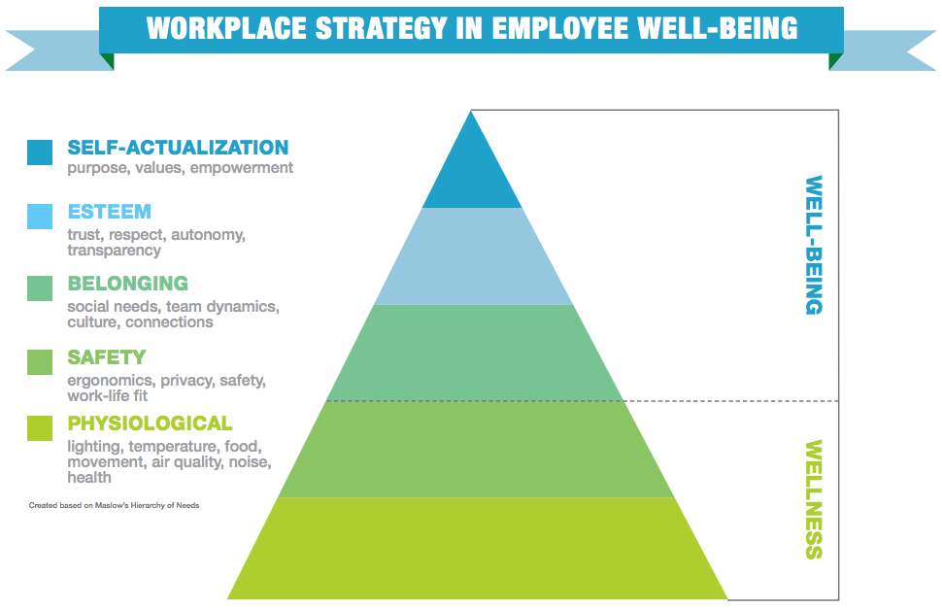
Source Credit: RJE Business Interiors (https://www.rjebusinessinteriors.com/2018/07/19/wellness-vs-well-being-in-the-workplace/)
What is the organisation’s broader/long-term employee wellbeing plan?
Now, focus on what can be done within this year and draw up a more detailed action plan for each chosen priority …
 | Inputs |  | Activities | Outputs | Outcomes
 | What are we investing?  - Budget, staff, time, facilities, other resources & flexibility/ accommodations?  - Are there any grants available?  - Who is leading this priority?  - What will be completed in-house vs external consulting? |  | What are we doing?  - Look closely to identify any associated risks; how will these be managed?  - How will you market this to employees & encourage engagement? | What are we producing?  - Are these activities feeding into the overall organisation goal? | Shorter-term  - How are you measuring these outcomes?  - How will you disseminate the findings & improve the programme? | Longer-term  - Are you tracking employee health trends?  - Are you tracking organisational measures such as productivity, job satisfaction, staff turnover, absence, injuries etc.?
Priority 1

(Are there any other departments/ workplace systems that connect to this priority?)

Staying on Track Checklist

Participation & Communication | Have we involved employees at every stage of the initiative?
 | Have we communicated clearly & consistently with employees & management about progress & outcomes of the initiative?
 | Do we need to consider the use of incentives & rewards to enhance engagement?
Sustainability | Is this initiative part of an overall workplace wellness policy?
 | Is the initiative aligned with the characteristics of our workplace including our core values & part of the company’s strategic plan?
 | Have we assigned a Healthy Workplace Team to champion workplace wellbeing efforts that includes a member from upper management?
Increasing Chances of Success | Are we assessing health outcomes at both the individual & organisational level to track improvements?
 | Are we remaining flexible, assessing the process of the initiative & making adjustments to improve it?
A great way to ensure employee participation AND increase sustainability AND increase success is to assemble a Healthy Workplace Team. However, it is important that flexible accommodations are made for the members so that the duties of the team are not adding to their workload in a negative capacity.

